S3 Bucket
Create an S3 Bucket (No Public Access)
Step 1: Open S3 Console

Go to AWS Management Console
Search for S3
Click Create bucket
Step 2: Configure Bucket

Enter a unique name (example: abu-s3-demo1)
Region: Choose your region

Step 3: Disable Public Access
Make sure the option is ON:
Block all public access - Enabled
Step 4: Disable ACLs
Keep default:
ACLs — Disabled (recommended)
Bucket owner enforced — Enabled
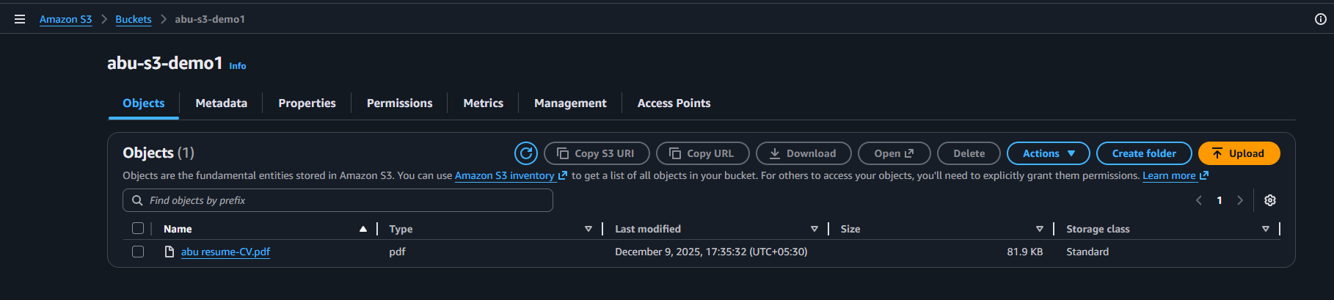

Upload Files to Bucket
· Open your bucket
· Click Upload
· Click Add files
· Select files from your system
· Leave permissions as default (private)
· Click Upload
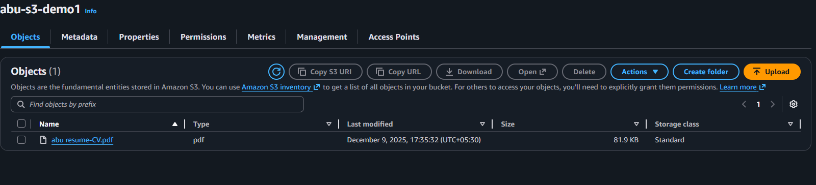
Enable S3 Logging (Server Access Logs)
Create a Bucket for Logs
Amazon recommends a separate bucket.
Go to S3 - Create bucket
Name it: abu-s3-demo2
Region: same region
Keep Block public access ON
Create bucket

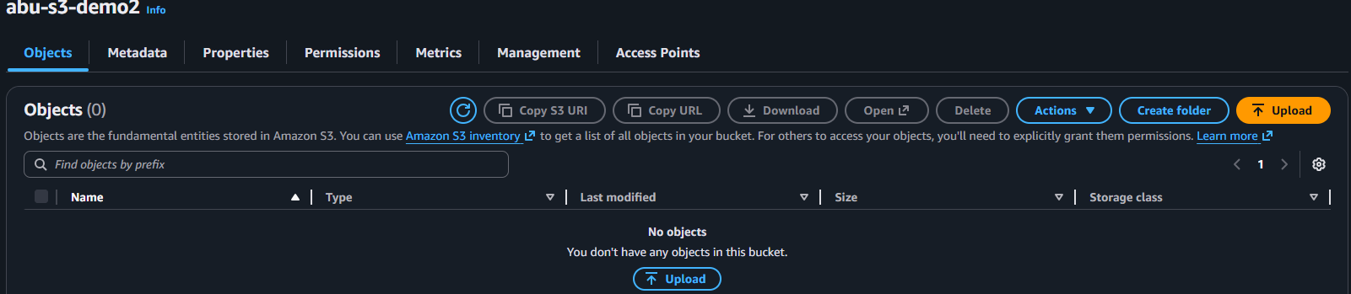
Enable Logging on the Main Bucket

Open your main bucket (example: abu-s3-demo1)

Go to Properties
Scroll to Server access logging
Click Edit
Turn ON: Enable

Choose Target bucket:
abu-s3-demo2
Click Save changes
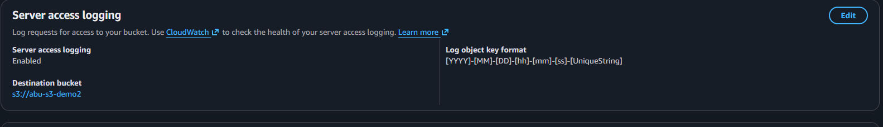
Enable S3 Event Logging to CloudWatch
Step 1: Open CloudTrail

Go to AWS CloudTrail
On left side, click Event history
Set Lookup attributes --- Resource name

Type your bucket name:
abu-s3-demo1
Now you will see:
Upload events
GetObject, PutObject logs
User identity
IP address
Timestamp
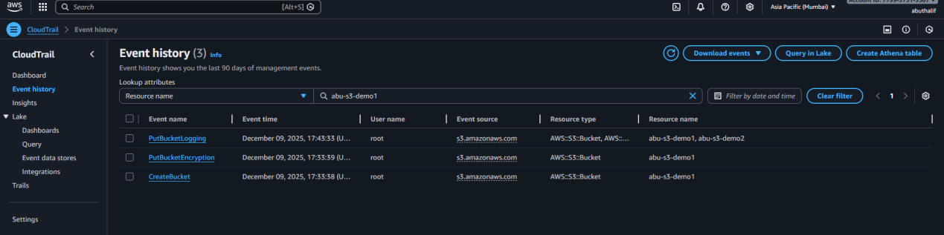
Enable CloudTrail to Send Logs to CloudWatch
Go to CloudTrail → Trails

Click Create Trail

Trail name: s3-demo-monitor

Storage location: choose an S3 bucket (CloudTrail default)

CloudWatch Logs:

Click Enable

Create a new CloudWatch log group

Click Next → Create Trail

Now all S3 API activity will be visible in CloudWatch logs.
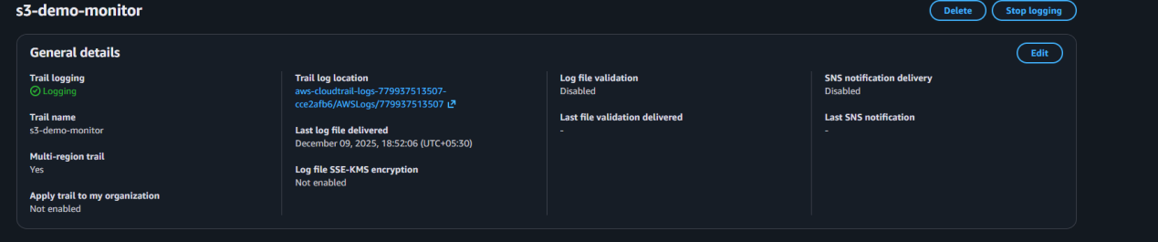
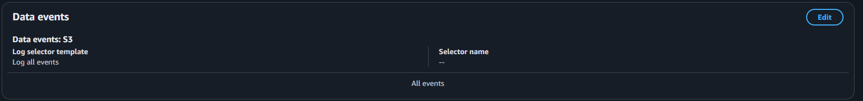
View Logs in CloudWatch
Go to CloudWatch
View Log Groups
Go to Logs -- Log groups
Open the log group created by CloudTrail
Example: /aws/cloudtrail/s3-logs-demo
View Log Streams
Click the latest log stream
You will see events like:
PutObject (file uploaded)
GetObject (file downloaded)
ListBucket
User details (IAM user, role)
IP address
Request time

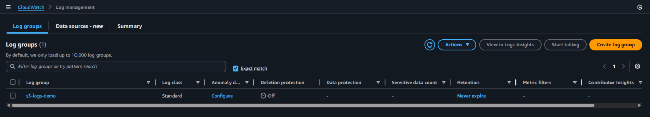
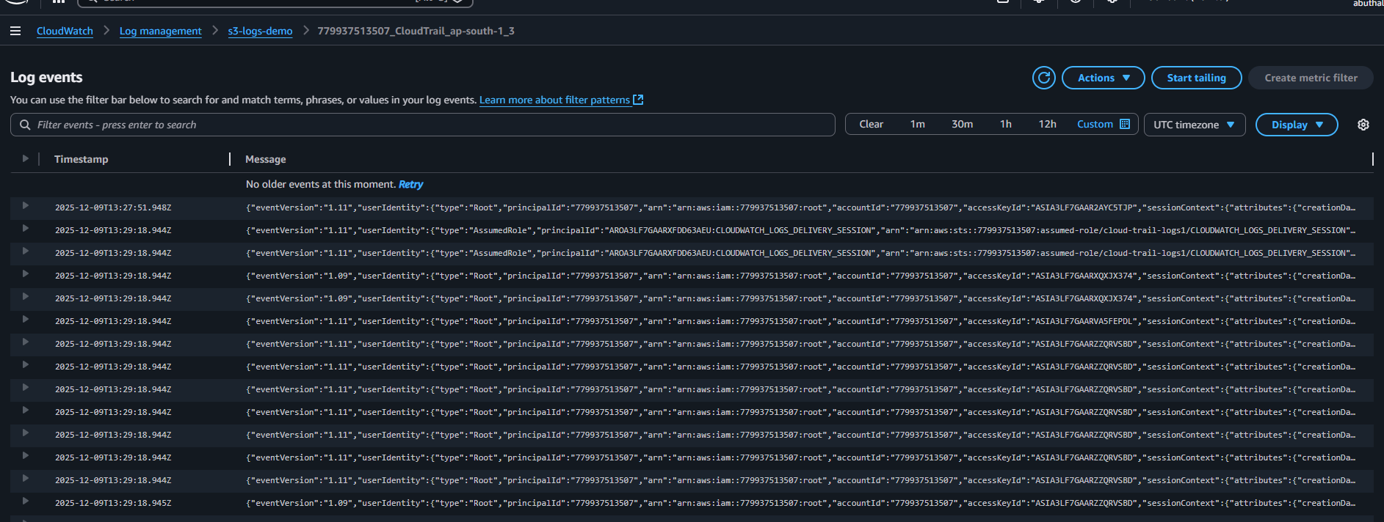
Launch Two EC2 Instances
Go to AWS Console
Search EC2
Click Launch instance
Name: system1 / system 2
AMI: Amazon Linux 2
Instance type: t3.micro
Key pair: Select/ create one
Network:
VPC: default or custom
Subnet:
Server-1 -- subnet A (ap-south-1a)
Server-2 -- subnet B (ap-south-1b)

Configure Security Group
Create a new SG:
Inbound:
HTTP --80 -- Anywhere
SSH --22 -- Your IP only
Outbound: Allow all
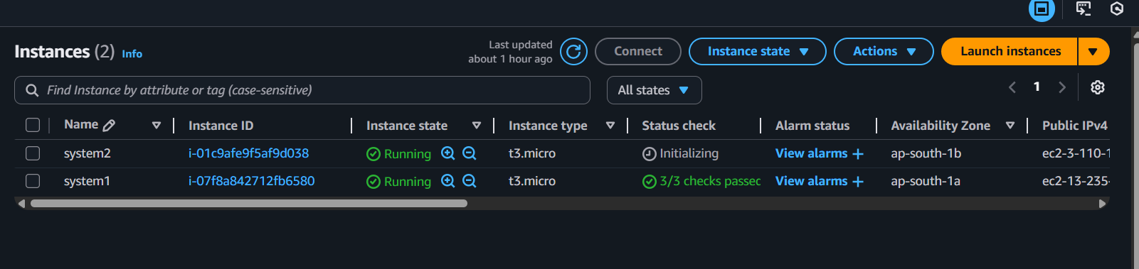
STEP 2: Create Target Group
1. Go to EC2 - Target Groups
Click Create target group
2. Configure Target Group
Target type: Instances
Protocol: HTTP
Port: 80
VPC: Default VPC
Name: web-target-group

3. Health Check
Protocol: HTTP
Path: /

4. Register Targets
Select both EC2 instances
Click Include as pending
Click Create target group
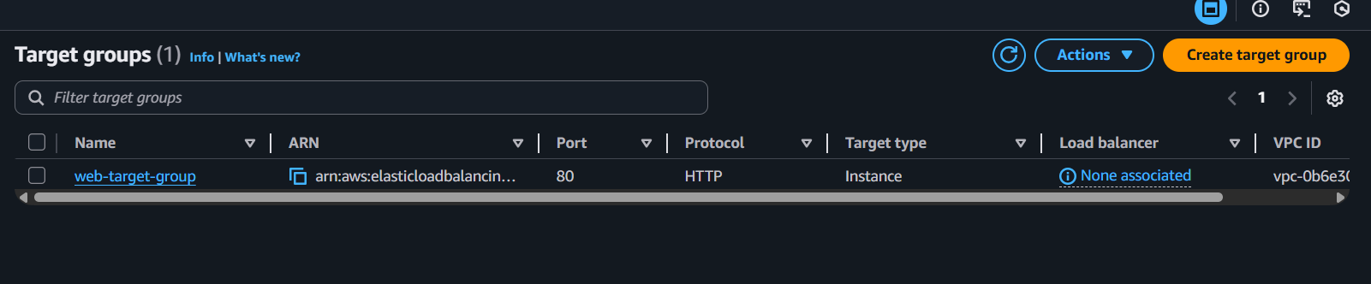
STEP 3: Create Application Load Balancer
1. Go to EC2 - Load Balancers
Click Create Load Balancer
2. Select Load Balancer Type
Choose Application Load Balancer
3. Configure Load Balancer
Name: web-alb
Scheme: Internet-facing
IP address type: IPv4
Listeners: HTTP (80)

4. Network Mapping

VPC: Default VPC
Select at least 2 public subnets

5. Security Group
Create or select a security group:
Allow HTTP (80) from 0.0.0.0/0

6. Listener & Routing

Default action → Forward to web-target-group

7. Create Load Balancer
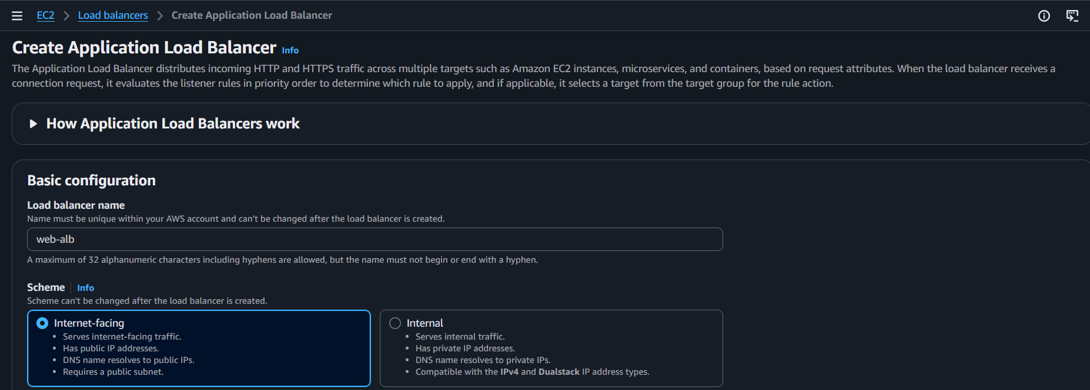
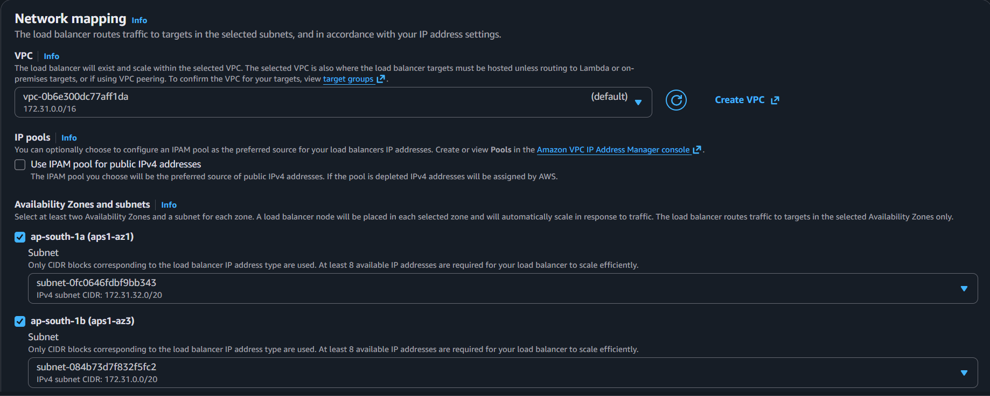
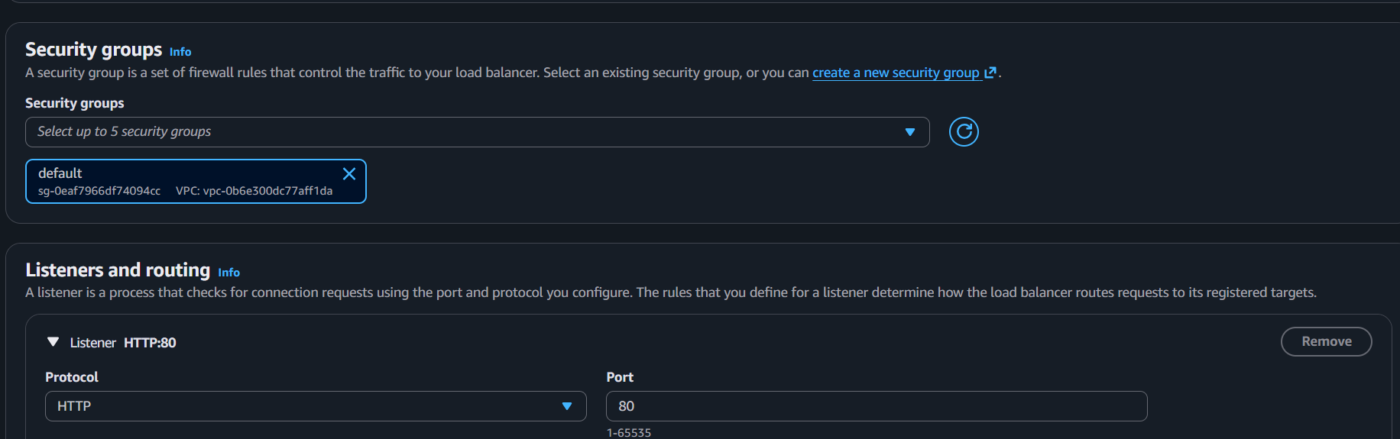

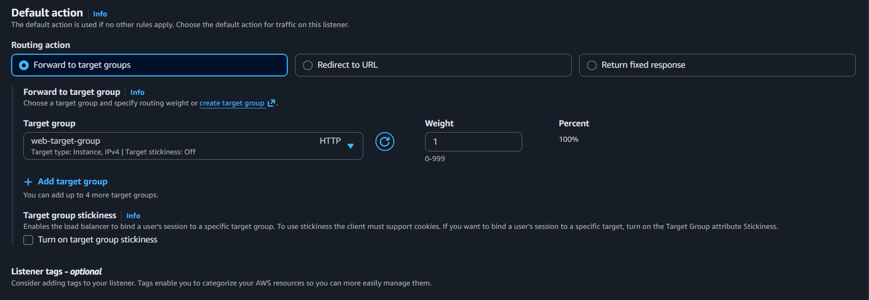
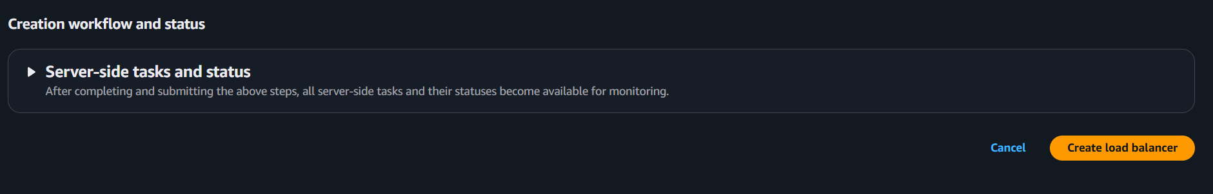

STEP 4: Verify Target Health
Go to:
EC2 - Target Groups - web-target-group - Targets.
Both instances should show Healthy
STEP 5: Access Application via Load Balancer

Go to EC2 → Load Balancers

Copy the DNS name of the ALB:

web-alb-123456.us-east-1.elb.amazonaws.com

Paste into your browser

